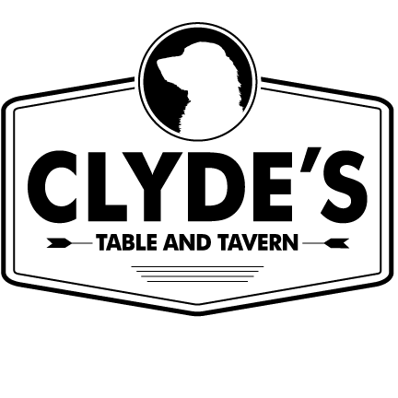
Puppy Plates
All puppy plates come with kids beverage and choice of one side item.
Side Items: French fries, Sweet Potato Fries, Onion Rings, Man N’ Cheese, Clyde’s Slaw, Black Eyed Peas, Green Beans, Collards, Side Salad
Kids 10 and under only please

Kids Mac N’ Cheese $6 Kids Quesadilla $6
Kids sized portion of our classic macaroni & cheese Kid sized cheese quesadilla
served with one side item Served with one side item
Kids Chicken Tender $6 Kids Hot Dog $5
Hand breaded chicken tender All beef hotdog
Served with one side item Served with one side item
Kids Pork Plate $6 Kids Burger $6
Smoked pulled pork Kids sized burger with cheddar
Served with 1 side item cheese served with 1 side item

Desserts
Ice Cream Sundae $3 Brownie A ‘La Mode $5
Vanilla ice cream served with whipped cream, Chocolate brownie topped with ice chocolate sauce & topped with a cherry cream & chocolate sauce

